Tuesday, January 22, 2019

CHAPTER 14

P.P.14.1

where .

At , ,
As , ,
At , ,

Thus, the sketches of H and are shown below.
0
1
0.7071
₀ = R/L

H

0
90
45
₀ = R/L

P.P.14.2 The desired transfer function is the input impedance.

The poles are at
–1.5505, –6.449
The zeros are at

–2, –3.

P.P.14.3

The magnitude and the phase plots are as shown in Fig. 14.14.

P.P.14.4

The magnitude and the phase plots are as shown in Fig. 14.16.

P.P.14.5

The magnitude and the phase plots are as shown in Fig. 14.18.
P.P.14.6
The gain is = 40 db = 20log₁₀(gain) or the gain = 100.

A zero at ,
A pole at ,
Two poles at ,

Hence,

P.P.14.7

Since ,

- At ,

At ,

At ,

P.P.14.8

Since ,

P.P.14.9

Clearly, ω = 435.9 rad/s

P.P.14.10 ,

i.e. a highpass filter.

The corner frequency occurs when .
, where

At the corner frequency,

Hence,

and the corner frequency is

P.P.14.11

Assuming high Q,

101

15.915 H

P.P.14.12 Given and
where C_{i} = 0.1–µF

$R_{i}=\frac{1}{2πf_{c}C_{i}}=\frac{1}{(2π)(2×10^{3})(0.1×10^{-6})}$

P.P.14.13 ,

Since ,

P.P.14.14

Therefore,

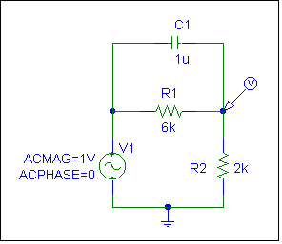
P.P.14.15 The schematic is shown in Fig. (a).

(a)

Use the AC Sweep option of the Analysis Setup. Choose a Linear sweep type with the following Sweep Parameters : Total Pts = 100, Start Freq = 1, and End Freq = 1K. After saving and simulating the circuit, we obtain the magnitude and phase plots are shown in Figs. (b) and (c).
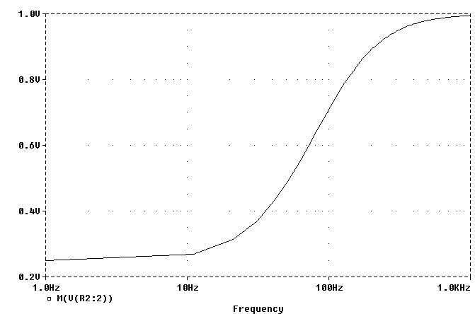

(b)

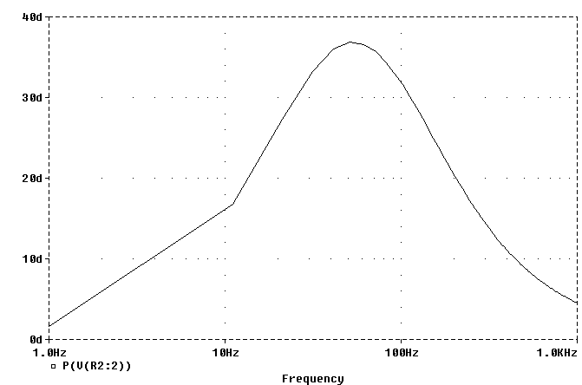

(c)

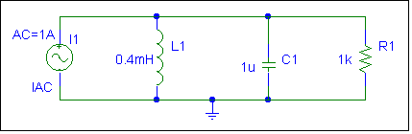
P.P.14.16 The schematic is shown in Fig. (a).

(a)

Use the AC Sweep option of the Analysis Setup. Choose a Decade sweep type with these Sweep Parameters : Pts/Decade = 20, Start Freq = 1K, and End Freq = 100K. Save and simulate the circuit.

For the magnitude plot, choose DB( ) from the Analog Operators and Functions list. Then, select the voltage V(R1:1) and OK. Another option would be to type DB(V(R1:1)) as the Trace Expression. For the phase plot, choose P( ) from the Analog Operators and Functions list. Then, select the voltage V(R1:1) and OK. Another option would be to type VP(R1:1) as the Trace Expression. The resulting magnitude and phase plots are shown in Figs. (b) and (c).
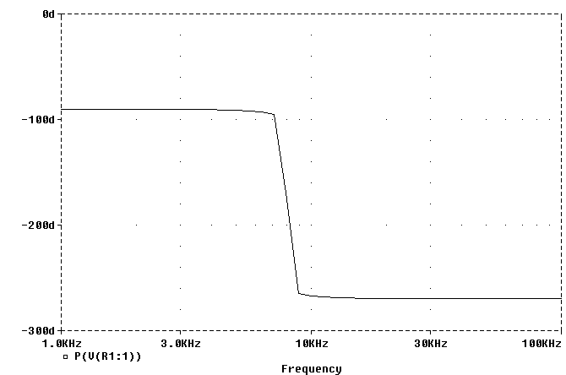
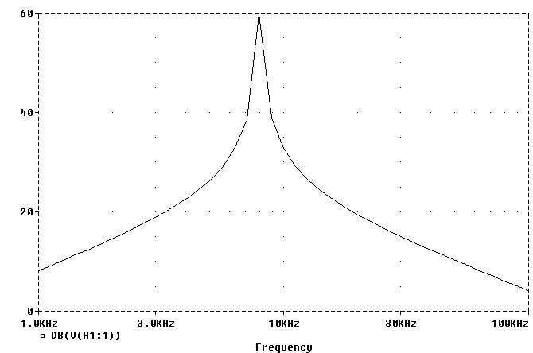

(c)

(b)
P.P.14.17
or

For the high end of the band,

For the low end of the band,

Therefore, C must be adjustable and be in the range .

P.P.14.18
For , and it passes frequencies in the range .

356 mH

P.P.14.19 and

